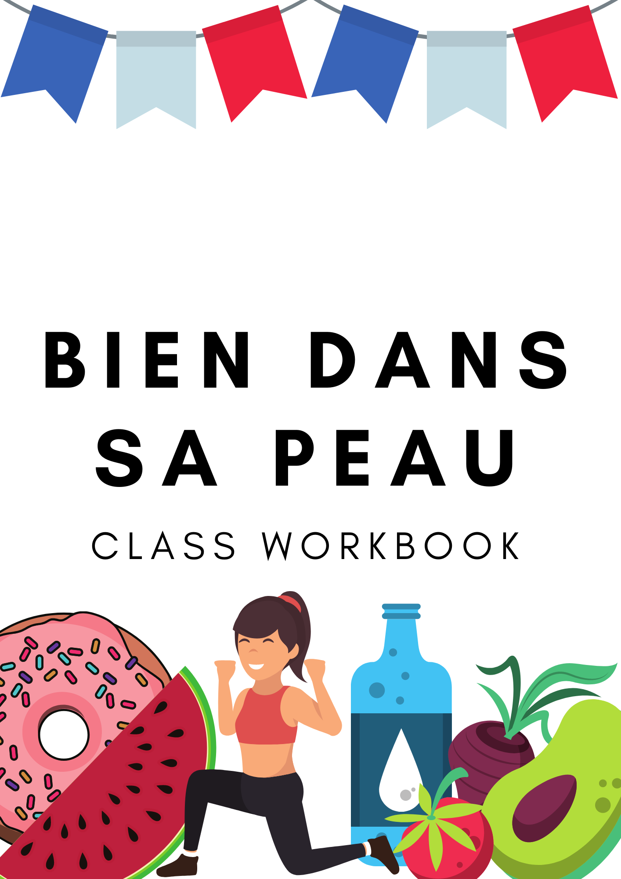
Unite 1: Touché!
Activité 1
Find the body parts in the wordsearch and add to the images below.
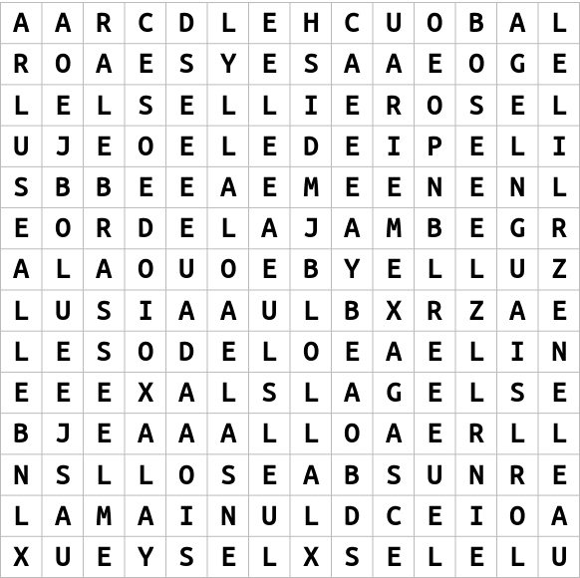
 | 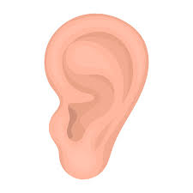 | 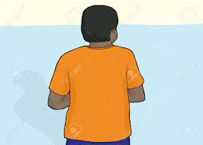 | 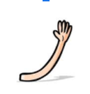
La ____________ | Les __________ | Le _________ | Le ___________ | Les ______________
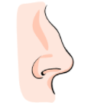 | 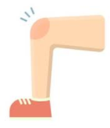 |  | 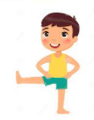 | 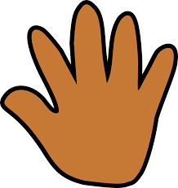
Le____________ | Le _____________ | La ________ | La ____________ | La ______________

Activité 2
Match the French to the English by colour coding them.
Grammaire
Á changes when it is followed by the definite article
E.g. á + le = au á + la = á la á + l’ = á l’ á + les = aux
la bouche | le bras | mouth | body | le genou
l’épaule | le corps | eyes | arm | les yeux
la tête | very often | shoulder | knee | head

Activité 3
Fill in the gaps with the correct form of a / a la /aux / a l’
1. J’ai mal ____ ________ tete. 2. J’ai mal _____ dos.
3.J’ai mal ______ yeux. 4. J’ai mal ____ _____ jambe.
5.J’ai mal ____ pied.
Activité 4
Label the image with the correct body parts in French

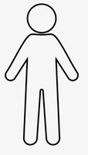

Unidad 2: Le sport et le fitness

Activité 1
Decode the phrases in the puzzle below. Then add them to the correct column.
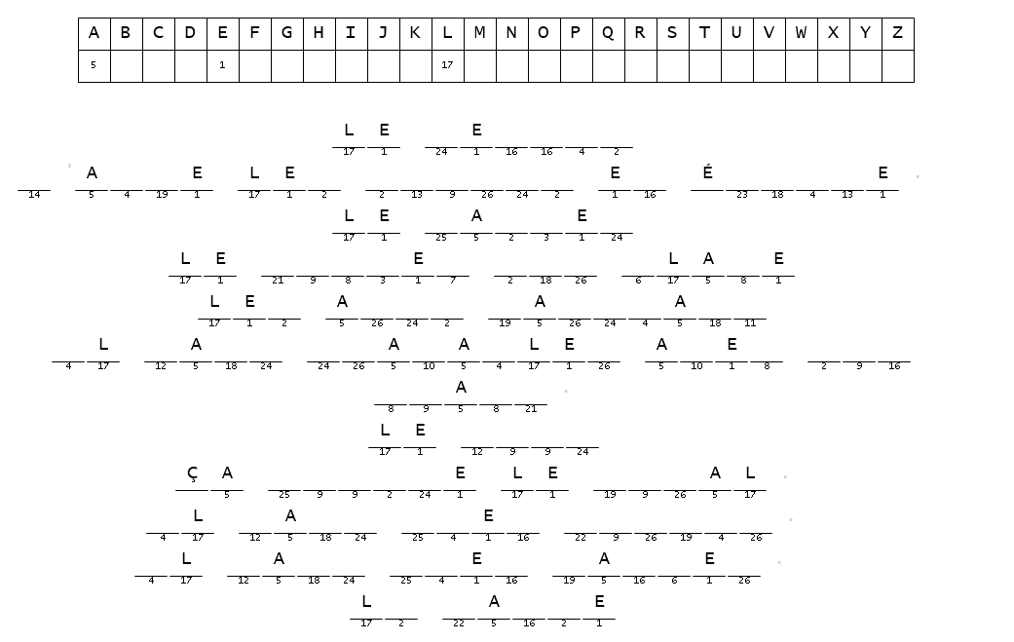

Sport | Opinion
Grammaire
Il faut
Il faut means ‘it is necessary to’ but in French you use it to mean ‘you must/ need to’ or ‘we must/need to’

It is normally followed by the infinitive

Activité 2
Complete the translations below
1. To be a good sportsperson, you must eat well.

2. You must like competition and work with your coach.

3. You must work well with your team.

4. To be a good sportsperson, you must sleep well.

6. You must also be motivated.

Activité 3
Read the text and complete the sentences below.
Le sport, c’est ma passion! Je joue au foot depuis dix ans, mais j’aime aussi le rugby, le hockey sur glace et la natation. Après avoir quitté le collège, j’ai étudié le sport à l'université et maintenant je suis prof d’EPS. J’adore ça!
Je joue au foot tous les dimanches avec mon équipe. Pendant l’hiver, j’aime jouer au hockey sur glace à Manchester. C’est un sport génial, mais un peu violent!
Anna
1. Anna has been playing football for ________________________________________.
2. When she finished school, she ______________________________________________.
3. Now her job is a ___________________________________________________________.
4. She plays football on ______________________________________________________.
5. She likes to play ice hockey during __________________________________________.
6. She thinks it is ______________________________________________________________.

