AQA GCSE Mini Assessments 1
Foundation
Question 1 Reading 2022 | Question 2 Writing 2020
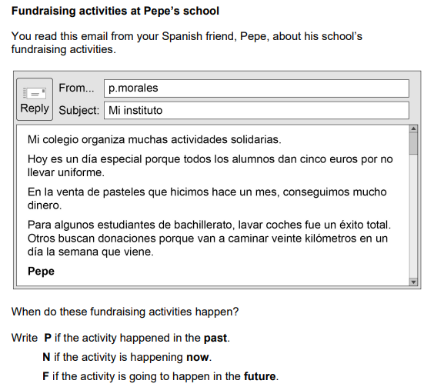  - Non-uniform day __________  - Cake sale ________  - Car washing ________  - Sponsored walk _________ | 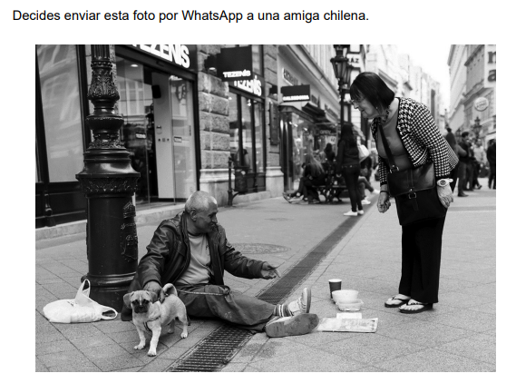  ¿Qué hay en la foto? Escribe cuatro frases en español.  1. _____________________________________________  2. _____________________________________________  3. _____________________________________________  4. _____________________________________________
Question 3 Writing 2019 | Question 4 Reading 2018
Tu amigo español, Jaime, te ha preguntado sobre tu colegio. Escríbele un email.  Menciona:  • profesores  • uniforme  • hora de comer  • deberes.  Escribe aproximadamente 40 palabras en español.  ______________________________________________________________________________________________________________________________________________________________________________________________________________________________________________________________________________________________________________________________________________________________________________________________________________________________________________ | 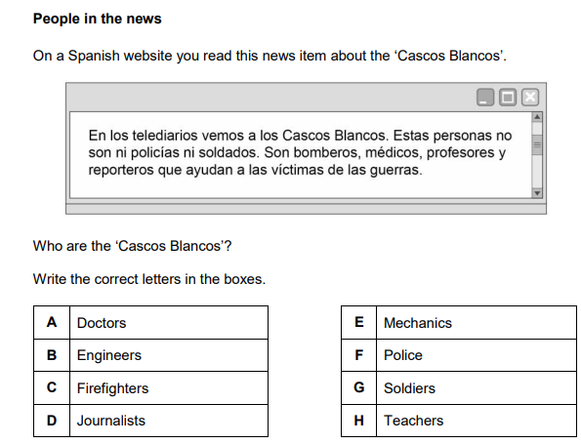
AQA GCSE Mini Assessments 2
Foundation
Question 1 Writing 2018 | Question 2 Reading 2018
Write a response to this bullet point. Write approximately 20 – 30 words.  - qué haces para proteger el medio ambiente  ________________________________________________________________________________________________________________________________________________________________________________________________________________________________________________________________________________________________________________________________________________________ | 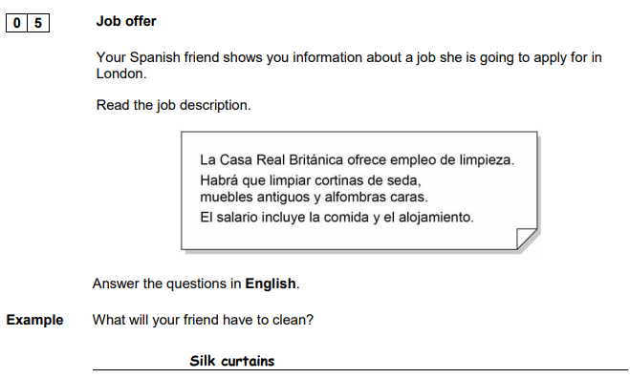  Write two more things.  _______________________________________________  What does the salary include? Mention two things. ________________________________________  _______________________________________________
Question 3 Writing 2019 | Question 4 Speaking 2018
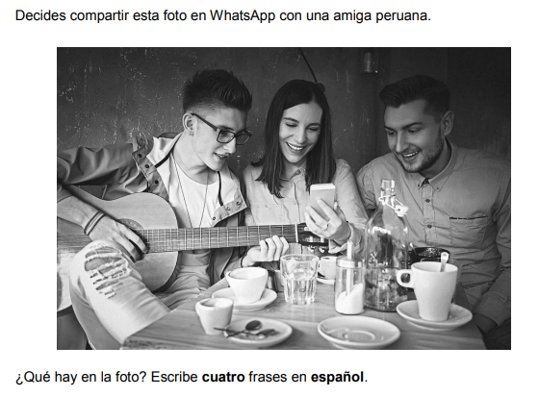  ¿Qué hay en la foto? Escribe cuatro frases en español.  1. _____________________________________________  2. _____________________________________________  3. _____________________________________________  4. _____________________________________________ | Write a suitable answer to each of these role play bullet points.  - Transporte al instituto  ________________________________________________________________________________  - Tu asignatura preferida y una razón  ________________________________________________________________________________  - ? Clubs en el instituto  ________________________________________________________________________________  - Clases – cuántas por día  ________________________________________________________________________________
AQA GCSE Mini Assessments 3
Foundation
Question 1 Speaking 2018 | Question 2 Reading 2021
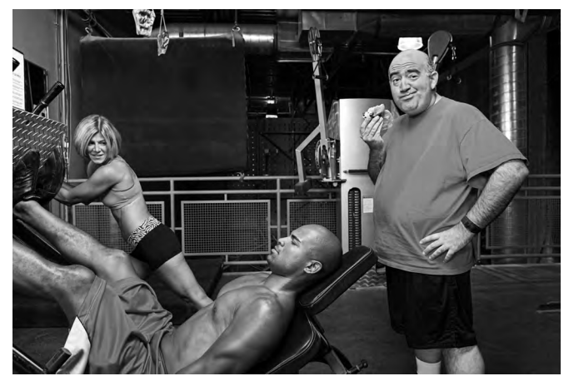  ¿Qué hay en la foto?  _______________________________________________________________________________________________________________________________________________________________________________________________________________________ | Your Spanish exchange partner sends you this message. Translate it into English for a friend.  En mi ciudad abrieron un instituto nuevo hace un año. Es el mejor de la región y a todos nos encanta. He decidido que voy a continuar mis estudios allí el próximo septiembre. ¡Qué emocionante!  _______________________________________________________________________________________________________________________________________________________________________________________________________________________________________________________________________________________________________________________________________________________________________________________________________________________________________
Question 3 Writing 2019 | Question 4 Reading 2022
Translate the following sentences into Spanish.  I send messages on my mobile.  ______________________________________________________________________________________________  I want a good job in the future.  ______________________________________________________________________________________________  I like to play basketball. I do more sport in the summer.  ______________________________________________________________________________________________  We went to a concert in the bullring.  ______________________________________________________________________________________ | 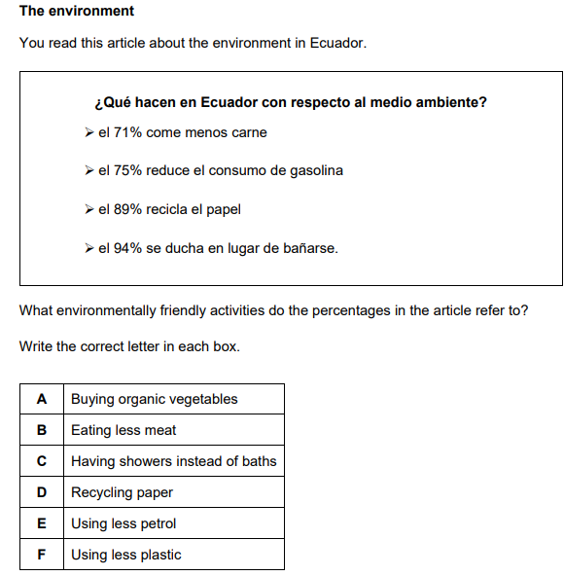  71% 75% 89% 94%

